Some Pleasant Mathematical Surprises!

**MAITREYO BHATTACHARJEE, IACS KOLKATA**

**SUMMARY –** The target of this brief article is to expose to the readers, some relatively obscure but genuinely beautiful mathematical and scientific stuffs, like the Ramanujan Constant, the apparent connection between Graph Theory and Thermodynamics, some mathematical constants, etc. Learning about such beautiful facts regarding things across which we come across regularly would not only arouse interest amongst the readers but also would develop a sense of appreciation for Science, in general.

**KEYWORDS – Cycle, irrational, transcendental, focal parameter, projectile, latus rectum, intensive variable, degrees of freedom.**

***“Coincidence is God’s way of remaining anonymous…”***

-Albert Einstein

Mathematics is a powerful and vast subject, having several applications across numerous diverse and complicated fields. The sheer ability of the subject, in giving rise to theoretical challenges or in helping to solve real life problems can by no means over stated. Right from describing the symmetry of crystals, where Group Theory has a say, to interrogating prisoners in a room, where Game Theory has a role to play to calculating the trajectories of heavenly bodies, where Differential Equations and Riemannian Geometry extend their help, Mathematics is UBIQUITOUS. Throughout ages, while solving tough problems or digging deep into theory, people working in the Scientific and Mathematical field have often come across some crossroads. Hugely unexpected connections have sprung up between seemingly disconnected domains of a discipline, and sometimes even among topics of different discipline. Mathematicians sometimes do themselves lack rigorous explanations for such queer happenings . Hence, it’s a common practise to term them as “coincidences,” as they are quite surprising. People are always in search for such connections, in case they might lead to some deep and interesting results. Sometimes, mathematicians find some numbers, whose values are unambiguously fixed, and they play a major role in varies different areas of study. At times, their popularity cross the barrier of academic disciplines and they become famous even in other spheres of the world. The golden ratio ($ϕ$) or the Universal Cosmological Constants are well known examples (Λ), but the target of this article is to focus mainly on some lesser known stuffs. Mostly High school level mathematics is required to grasp these, so they can be comprehended by a large number of people, even by someone who currently has no direct connection with the mathematical world. The words “similarities” or “constants” may sound a bit recreational in some aspects, but the mathematical or scientific treatment which leads to either of them is no less than formal and has lot of insights to gain from it. Thus, its more or less essential to study and ponder about such ideas and results at some point of time in one’s life. It does strongly give some positive vibes and most importantly, motivates to learn more, to explore more and to understand more and more. Let us throw light on some mathematical jewels and enrich, inspire and motivate ourselves to the fullest!

* ALIKE, BUT NOT THE SAME….

The first phenomenon that we would discuss links two results which are separated by almost 2 centuries.

**EULER’S FORMULA FOR PLANAR GRAPHS**

Let’s begin things by stating Euler’s very well-known and widely used formula. Consider a planar graph with v vertices, e edges and f faces. Then the formula states that $v-e+f=2$. We can prove this by the Induction on the number of edges of the graph.

* **Base Case**: If e = 0(that is no edge), the graph consists of a single vertex with a single region surrounding it. So we have 1 − 0 + 1 = 2 which is clearly true.
* **Inductive Step**: Suppose the formula works for all graphs with maximum n edges. Let A be a graph with (n+1) edges.

1. Case 1: G doesn’t contain a cycle. So G is a tree, which has a single face(the plane containing it). By definition, it has (n+1) vertices and n edges. Hence, $v-e+f=\left(n+1\right)-n+1=2$. Hence, proved!
2. 3 Case 2: G contains at least one cycle. Pick an edge p that’s on a cycle. Remove p to create a new graph G′ . Since the cycle

separates the surrounding plane into two regions, the regions to either side of p must be distinct. When we remove the edge p, we simply merge these two regions. So G′ has one region lesser than G. Since G′ has n edges, the formula works for G′ by the induction hypothesis. That is $v^{'}-e^{'}+f^{'}=2$. But v ′ = v, e ′ = e − 1, and f ′ = f − 1. Substituting, we find that $v-\left(e-1\right)+\left(f-1\right)=2$. Hence,

$$\boxed{v-e+f=2}$$

This is the mathematical part. But this is not at all the end.

**GIBB’S PHASE RULE**

The Phase Rule was first discovered by the eminent Physical Chemist Josiah William Gibbs in his historic paper “**On the Equilibrium of Heterogenous Substances**” which was published between 1817 and 1878. Hence, the rule bears his name.

For a moment, we will shift to Chemistry (which is not the forte of most Math Lovers, what an irony!). Consider a thermodynamic system in equilibrium, which is described by the variables **p**(pressure), **T**(temperature) and **V**(volume). Let, **C** denote the number of components of the system, that is the minimum number of independent species needed to define the composition of all the phases present, **P** be the number of phases present in equilibrium(pure water is a one component phase, (water + ethanol) forms a 2 component phase, etc) and **F** denote the number of degrees of freedom. Over here, “degrees of freedom” signifies the minimum number of intensive variables(mole fraction, pressure, temperature) that must be specified to *completely* characterize the system. Let $x_{i}$ denote the individual mole fractions of the components. A *vital* prerequisite of the rule is that the components have to be non-interacting, i.e., they should not react with each other. So now we have to quickly carry out some calculations.

(a)

* STEP 1 – We have to count and note the total number of intensive variables. The pressure p, and the temperature T, count as two. We know that –

$$\sum_{i=1}^{C}{x_{i}}=x_{1}+x_{2}+x_{3}+⋯+x_{c}=1$$

Hence, we need to know only (C-1) mole fractions to specify a phase as the other can be easily determined by subtracting the sum of the other variables from 1. Also, there are P phases, so we see that there are in total P(C-1) composition variables. Considering pressure and temperature, the total number of intensive variables become $P\left(C-1\right)+2$.

* STEP 2 – In equilibrium condition, the molar Gibbs energy of any component J should be the same in all the P phases. Thus,

$$G_{1}\left(J,m\right)=G_{2}\left(J,m\right)=⋯=G_{P}\left(J,m\right)$$

Thus, for each component J, there are P-1 such equations to be satisfied. Taking into account C number of components, the total number of equations become $C\left(P-1\right)$.

* STEP 3 – Each and every equation decreases the freedom to vary one of the $P\left(C-1\right)+2$ intensive variables. Hence, the total number of degrees of freedom –

$$∴ F=P\left(C-1\right)+2-C\left(P-1\right)=C-P+2$$

$$\boxed{F=C-P+2}$$

**DOES IT SEEM TO HIT AT SOMETHING?**

If it does not, the following surely does –

$$\boxed{F-C+P=2}$$

**Correct you are!** It is that very formula, which was discussed in the first part. The Gibbs Phase Rule in *Thermodynamics* does bear a strange resemblance with the Euler’s Formula in Graph Theory. Comparing the two equations, we see that if they are truly the same in some sense, then the following analogous relations must hold –

**Faces ~ Degrees of Freedom**

**Vertices ~ Phases**

**Edges ~ Components**

But unfortunately, studies have revealed that the 2 formulas are in no way equivalent and have no deep connection between them. One very trivial reasoning behind this can be that F,V and E in Euler’s Formula have to be $≥1$, but that is not the for Phase Rule. The value of the variables can be 0 as well. To study whether there exist any connection or not, we construct the following figure which roughly represents a graph –

(1)

However, each edge borders only two faces and has only two vertices. This pair-wise relationship is absent in Gibbs’ phase rule. It would make sense if each component could only be present in two different phases and if each component was somehow paired up with two degrees of freedom. *BUT*, the triple point of water is itself a prominent counterexample in this regard!

Hence, although visually aesthetic, the similarity of the 2 formulas has limited theoretical prospects.

* ALMOST THERE…

I do not have the recollection of the last time when I had refrained from making any sort of approximation during my Physics or Chemistry practical classes. It is indeed our natural tendency to be biased towards *integers* or natural numbers, and not fractions or decimals. In fact, even within the integers, we are more comfortable with multiples of 10, i.e., the numbers having trailing zeroes. The more 0s, the better. But alas, in the real world, we hardly encounter things which we personally prefer. In this regard, we recall one famous quote by the Hungarian-American mathematician John Von Neumann –

“*The truth is too complicated to allow anything but approximations.”*

Indeed, in mathematics, there are many universal constants which are not integer themselves, but are **remarkably** close to them. They can be used to approximate the integers. Such close they are, that we cannot help but wish, only if they had been an integer, a proper integer!

1. **Ramanujan Constant –** This was actually first noted by Hermite, but this name was given Simon Plouffe. The irrational constant –

$$\boxed{e^{π\sqrt{163}}}$$

is popularly referred to as the Ramanujan Constant . Want to know its value? 262537412640768743.**9999999999992500…** Maybe, the perfect numerical embodiment of SO NEAR, YET SO FAR! The occurrence of the number 163 here is not random. It is a *Heegner Number,* a class of number which have deep number theoretic properties. An interesting thing to be pointed out with respect to the Ramanujan constant is that, once, Martin Gardner, the legendary American Popular Mathematics Writer, had played an April Fool’s joke using it in the magazine Scientific American. In the month of April in 1975, he had remarked that $e^{π\sqrt{163}}$ was an integer and that Ramanujan has conjectured in 1914(Srinivasa Ramanujan(1887-1920), the prolific Indian Mathematician, himself never mentioned this particular number. Instead, he used $e^{\sqrt{58}}$ and some other brilliant examples. In terms of popularity, these constants can never match the celebrated Hardy Ramanujan Number, or even the Ramanujan-Soldner constant). Gardner had, however later confirmed that it was just a hoax. Mathematics can be hilarious at times too!

(b)

b) **Feynman Point –** This one is about $π$, reference to which would be made in the next section as well. This is also known as “**six nines in pi**” . The main idea is the occurrence is the 6 consecutive digits of 9 starting from the 762nd position in the decimal expansion of $π$. One popular idea among many people is to memorize the digits of *π* till till the 761th position and then end the recitation by uttering “**nine nine nine nine nine nine..”** , thus convince the layman listeners that $π$ is rational! Indeed, Douglas Hofstadter, the pioneer of this observation, had once remarked that-

“*I myself once learned 380 digits of π, when I was a crazy high-school kid. My never-attained ambition was to reach the spot, 762 digits out in the decimal expansion, where it goes "999999", so that I could recite it out loud, come to those six 9's, and then impishly say, "and so on!" “*

The attribution of this thing to the famous Physicist Richard Feynman is a bit controversial. While it is believed that he had mentioned about this in one of his lectures, there is no proper evidence of the claim.

* LIKE CIRCLE, LIKE PARABOLA!

I would finally wind up by mentioning about another beautiful result. All of us are aware of $π$ and the supreme role played by it in describing nature through mathematical and physical laws. What is it basically? Nothing but the ratio of the circumference to the diameter of a circle, of **any** circle. Its value is close to 3.141 . I call it close because it does not have any finite representation, as it is “irrational.” Countless number of identities and interesting facts exist about $π$ exists, and I am not going to focus on them here. Instead, I would like to highlight another such mathematical constant, whose popularity is much lower as compared to the former.

Bring a *parabola* in picture. Visualizing a parabola is not a difficult task, and cricket loving people do regularly see them in cricket grounds, whenever the batsman hits the ball for a six. Basically, the path followed by a particle in a projectile motion(like, the motion of a ball from a batsman’s bat, the motion of a bullet from the nozzle of a gun or a golf ball in flight) is parabolic. Mathematically speaking, parabola, like circle, hyperbola or ellipse, is a conic section, which are very popular mathematical figures. Over here, we would observe a peculiar property of parabolas.

Without loss of generality, consider a parabola $y=\frac{x^{2}}{4a}$, $a ≠0$. There is a slight catch here. We can assume the parabola to be of this particular form, i.e., with its vertex coinciding with the origin. If this is not the case, i.e., if the vertex lies somewhere else, then we will simply “shift” the origin to the vertex, and all the other properties of the system essentially remain the same. Now lets visualize the parabola, which would aid us to compute our result–

(2)

The point labelled as F is called the **focus** and it has coordinated (0,a). The blue line, perpendicular to the focus and intersecting the parabola in two distinct points, is called the **latus rectum**. The red curve is called the **arc subtended by the latus rectum**($L_{1}$)**,** due to obvious reasons. The green line is called the **focal parameter**(L2)**.** Observe that the other endpoint of this line is the reflection of the focus about the origin. Hence, its length is $2a$. We are mainly concerned about the red curve and the green line. Let’s calculate their ratio.

$$L_{1}=\int_{-l}^{l}{\sqrt{1+m^{2}\text{d}}x ; m=\frac{dy}{dx}} , l=\text{semi latus ractum}=2f$$

$$\frac{dy}{dx}=\frac{x}{2a} , m^{2}=\frac{x^{2}}{4a^{2}}$$

$$L_{2}=2a$$

Hence, $\frac{L_{1}}{L_{2}}=\frac{L_{1}}{2a}=\frac{1}{2a}⋅\int_{-2f}^{2f}{\sqrt{1+m^{2}}\text{d}x}=\int_{-1}^{1}{\sqrt{1+s^{2}}}\text{d}s , \text{where }x=2sa$

On calculating, the value comes out to be $\boxed{\ln\left(1+\sqrt{2}\right)+\sqrt{2}}$. Now, **take a moment.** Try to get what just happened. Did we assume some special condition? NO. Does the final answer contain any variable? Again a NO. So, is this valid for all possible parabolas? YES! Hence, this is a constant, a **strange mathematical constant** just like $π$ or $e$, having an approximate value of 2.295. Like its two well-known counterparts, the universal parabolic constant, often denoted as $P$, is also an irrational number. Like $π$, $P$ is also a transcendental real number, meaning it is **not** a root of a polynomial equation with rational coefficients. Transcendence has numerous implications in Pure Mathematics, and is a well-researched topic. We would demonstrate another property of the Universal Parabolic Constant.

Consider a unit square with centre $\left(0.5,0.5\right)$. It contains numerous random points inside it as shown below-

(3)

Now, if we calculate the expected distance of the point to the centre of the square($D_{1}$) and to any fixed vertex of the square($D_{2}$), we see that –

$$D_{1}=\int_{0}^{1}{\int_{0}^{1}{\sqrt{{\left(x-0.5\right)}^{2}+{\left(y-0.5\right)}^{2}}}} dxdy$$

$$D_{2}=\int_{0}^{1}{\int_{0}^{1}{\sqrt{x^{2}+y^{2}}}dx}dy$$

After calculation, it is found that $D_{1}=\frac{P}{6}$ and $D_{2}=\frac{P}{3}$!

So, its time for conclusion. I have something in store to end this mathematical journey. Cold and conventional end notes should really be replaced by some adroitly planned stuffs, so that the reader ends reading the article on a positive note. So here goes the last gem –

$$\boxed{\frac{987654321}{123456789}=8.0000000729}$$

I still vividly remember the thrill I had experienced when I had discovered this myself. What did it cost? Just the non-zero digits of the number system and the division operation could take us *so, so* close to 8. So simple yet truly remarkable. That’s all for now. I hope I could unravel some beautiful facts and results in front of the readers, and persuade them to begin their quest in search of more such treasures, which are often encountered in Mathematics and Sciences. I wish them good luck!

**References –**

[1] Tales of Impossibility: The 2000-Year Quest to Solve the Mathematical Problems of Antiquity, David S. Richeson.

[2] Our Mathematical Universe: My Quest for the Ultimate Nature of Reality, Max Tegmark.

[3] Mathematical Constants, Steven R. Finch.

**IMAGES…**

**1.**

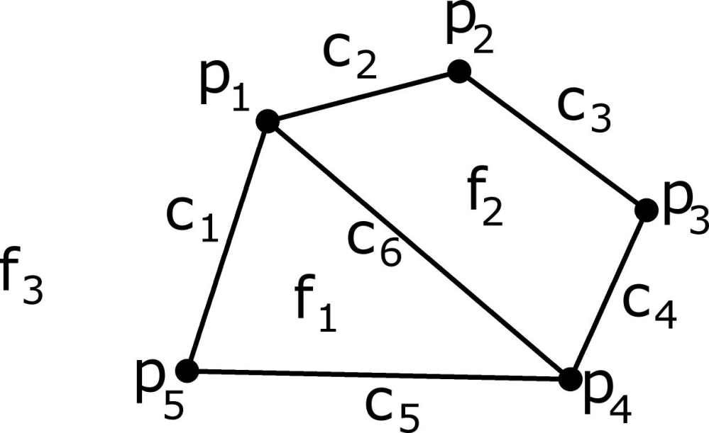

**Pictorial representation of the two formulas**

**COURTESY : David Richeson’s Blog DIVISION BY ZERO**

To be included in the space marked by (1).

**2.**

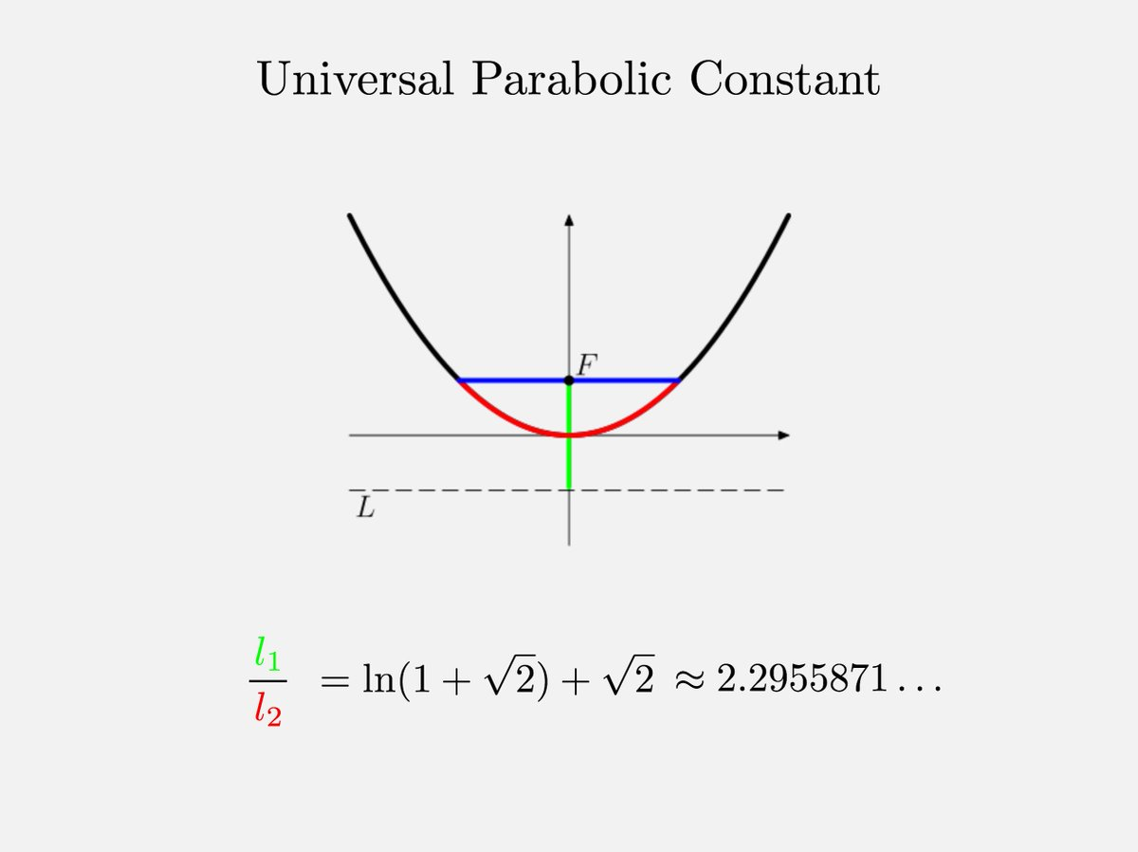

**The parabola**

**COURTESY : Fermat’s Library**

To be included in the space marked as (3)

**3.**

. . . . . . . . . . . . . . .

. . . . . . .

. . . . . . . .

. . . . . . . .

. . . . . . . . .

. . . . . . . . .

. . . . . .

. . . . .

**Unit square with some random points**

This is made by me.

To be included in the space marked as (4)